**Java Programming Academy**

**Pacific Tech Camps**

To continue learning Java with Greenfoot, we recommend that all students install Greenfoot on their home computers.

The Greenfoot software and Java Development Kit are FREE!

Installation Instructions

1. Visit [www.Greenfoot.org](http://www.Greenfoot.org)
2. Click on “The Software” in the lower left corner of the page.
3. Click on “Download JDK”

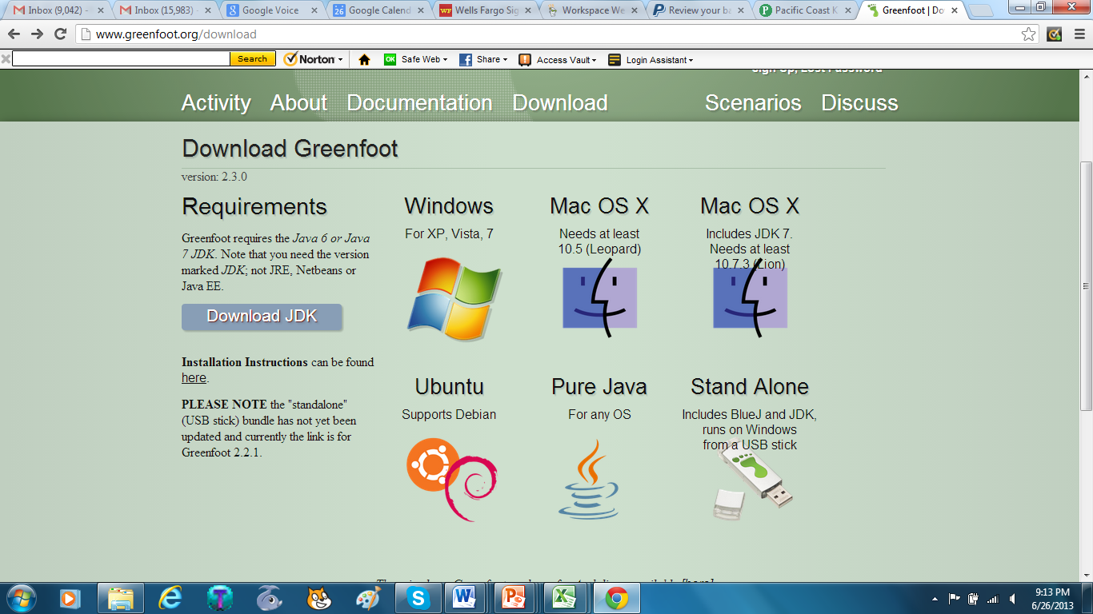

1. Click on Java Platform (JDK)

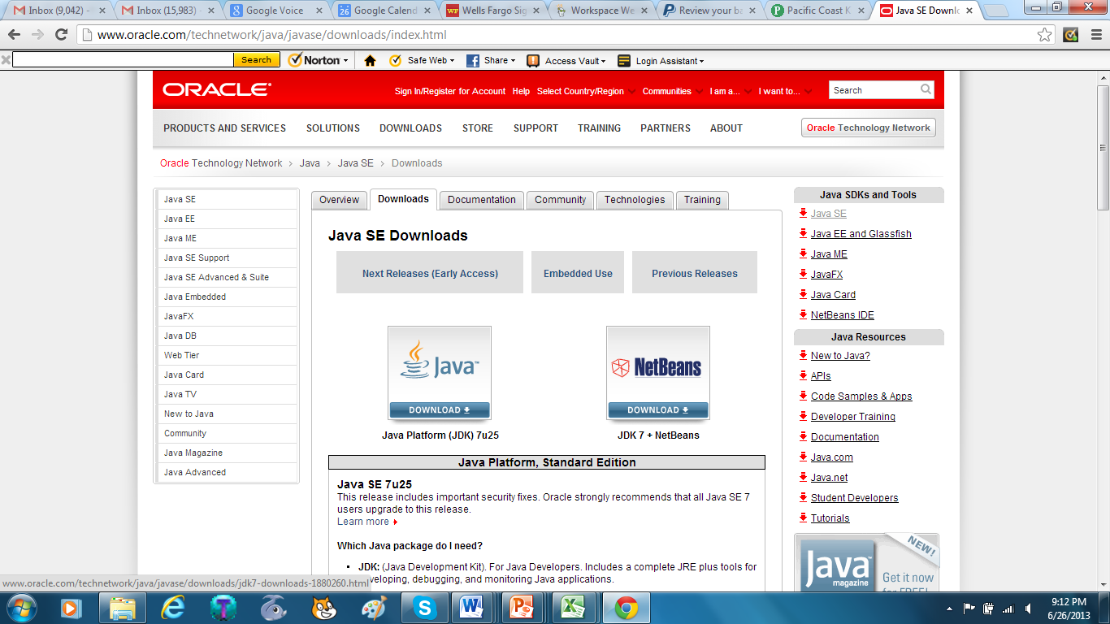

1. Install the latest Java Development Kit. For best performance in Windows even if you have a 64 bit operating system, please select the “Windows x86” option. 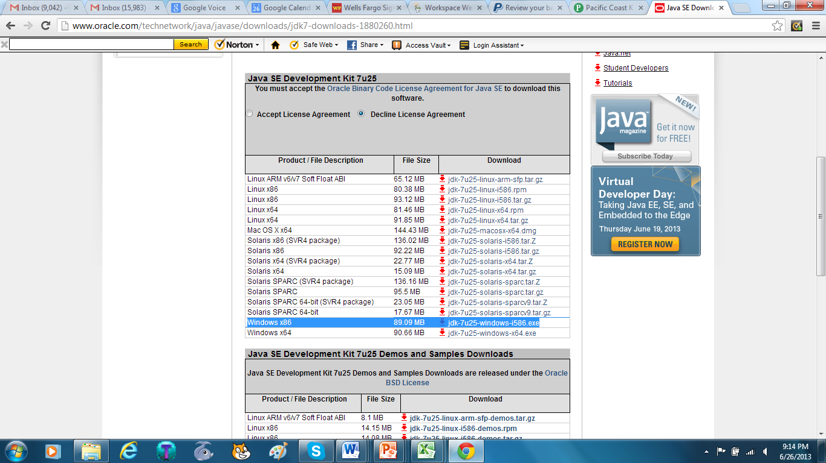
2. Return to the Greenfoot software download page at: <http://www.greenfoot.org/download>
3. Install the version of Greenfoot for your computer’s operating system.
4. Once installed, students can open all the programs that they created while attending the Java Programming Academy.